MOM Website

SRS

Introduced by SE2018G15

|  |  |  |  |  |
| --- | --- | --- | --- | --- |
| Version | Written By | Reviewed By | Approved By | Date |
| 1.0 | Shimaa Mahmoud Mohamed  Manar Ahmed AbdelGawad | Aya Abdelsamea Mohamed  Mai AboElmaaty Mohammed  kholoud Hessen Samy | Enjy Osama  Shorouk Mohamed mohamed | 24-11-2018 |
| 2.0 | Mai AboElmaaty Mohammed  kholoud Hessen Samy  Shorouk Mohamed mohamed | Enjy Osama  Aya  Abdelsamea Mohamed | Manar Ahmed AbdelGawad  Shimaa Mahmoud Mohamed | 2-12-2018 |

**Introduction**

**Executive Summary**

MOM is an online care offering information and service to every pregnant and after-pregnant mom. This site should offer effective answers and information covering each month of pregnancy. It should offer proper feeding methods and exercises for the mother. MOM can be used by every pregnant women and new mom. MOM can be used to help them contact with their doctor at any time easily by Online Discussion. MOM provides safe and credible information Securely.

**Document Overview**

This document Specifies functional and non-functional system requirements in details,

and provides more technical information

like:

* System Description
* System Modules
* System Functions
* System Models
* Non-Functional Requirements

**References**

* week 6 (SRS Slides) <https://sites.google.com/view/asusoftwareengineering/lectures>
* IEEE Standard SRS Document

Download link:

<https://web.cs.dal.ca/~hawkey/3130/srs_template-ieee.doc>

**System Description**

**Introduction**

MOM is an online care offering information and service to every pregnant and after-pregnant mom. This site should offer effective answers and information covering each month of pregnancy. It should offer proper feeding methods and exercises for the mother. MOM can be used by every pregnant women and new mom. MOM can be used to help them contact with their doctor at any time easily by Online Discussion. MOM provides safe and credible information securely

**Modules**

* MOM Module
* Doctor Module
* Nutrition Module
* Exercise Module
* Medical Tests Module

**Users**

* Doctors
* Tripods and Mothers

**System Users**

**Doctors**

There are two types of doctors; there are gynecologist and doctors of babies. They take care of mothers and babies, follow up with them and give them information and medical tips they need.

**Tripods and Mothers**

They will sign up with their special information so that we could make required calculations. They could find articles about variant subjects such as useful exercises for them, nutrition, and psychological changes. We will send them notifications about every change with them and advise them.

**System Modules**

1. **MOM Module**

This module provides calculating on the month of pregnancy to know which month and days exactly she is in depending on the date she will enter it during registration on the website, so we can help her know which food and exercise suitable for her.

It also calculates rate of change in her weight and remind her with things she wrote so she couldn’t forget by sending notification for example.

1. **Doctor Module**

create an account for him, we will take some information from him then he will be able to communicate with pregnant women to help her.

1. **Nutrition Module**

It will provide Moms with healthy food for her and the food she mustn’t eat, depending on date she entered before and knowing which stage she is in and if she have sensitivity from any food.

1. **Exercise Module**

Provides the exercise she can practice and exercise she must not do, depending on her stage.

1. **Medical Tests Module**

Will show her how the result of her medical tests, Good or bad depending on her inputs.

**System Functions**

1. **MOM Module Functions**

**1.1 Calculating the month of pregnancy**

Description: we will help her to know which month and days exactly she is in to know which stage of Pregnancy she is to take it after we know to the Things appropriate with her.

Inputs: we will take the date when she will give birth in.

Outputs: take her to food, exercise, calculation and Information relate to her stage of pregnancy.

Pre-conditions: due date she will enter it during registration on the website.

Post-conditions: she will find the thing that relate to her in her account.

**1.2 ADD Weight**

Description: she will enter her weight then find a daily Chart. She will know the rate of change for her weight from this chart.

Inputs: Her weight.

Outputs: chart, she will follow it to observe changes in her weight.

Pre-conditions: she should know her weight to give it for us.

Post-conditions: the rate of change in her weight During months of pregnancy through a chart she will find it.

1. **Doctor Functions**

**2.1 Sign up and communication**

Description: first he will create an account for him, we will take some information from him then he will be able to communicate with pregnant women.

Inputs: information help MOMs to know the doctor and ask him about they need.

Outputs: new profile for him and communication with MOMs.

Pre-conditions: he will enter some info like his name, email and specialization to enter and communicate with moms.

Post-conditions: he will take part from database and web site for him and he will be able to answer the inquiries for moms they need.

1. **Nutrition Functions**

**3.1 The right food**

Description: MOMs will find the healthy food for her and the food she mustn’t eat.

Inputs: due date she enters before and knowing which stage she is in and if she sensitivity from any food.

Outputs: she will find the diet that she should follow It.

Pre-conditions: month of pregnancy of her and food she can’t eat it because of sensitivity or illness.

Post-conditions: she will find in her month which food appropriate and healthy for her and it will dynamically change every month for her and her baby.

1. **Exercise Functions**

**4.1 Do/not this exercise**

Description: she will find this exercise she can practice and exercise, she can’t do them.

Inputs: due date of her.

Outputs: types of exercises she should practice.

Pre-conditions: month of pregnancy of her and if she has any sensitivity or illness.

Post-conditions: she will find tips for her month through which exercise appropriate and good for her and it will dynamically change every month for her and her baby.

1. **Medical Tests Functions**

**5.1 Normal result or not**

Description: we will take the result of her medical tests and inform her if it is good or not.

Inputs: Result or tests she performed.

Outputs: good or not and what should she do.

Pre-conditions: she must do some of tests and give us the results of them.

Post-conditions: she will know what these results mean.

**System Models**

**Use Case Diagrams**

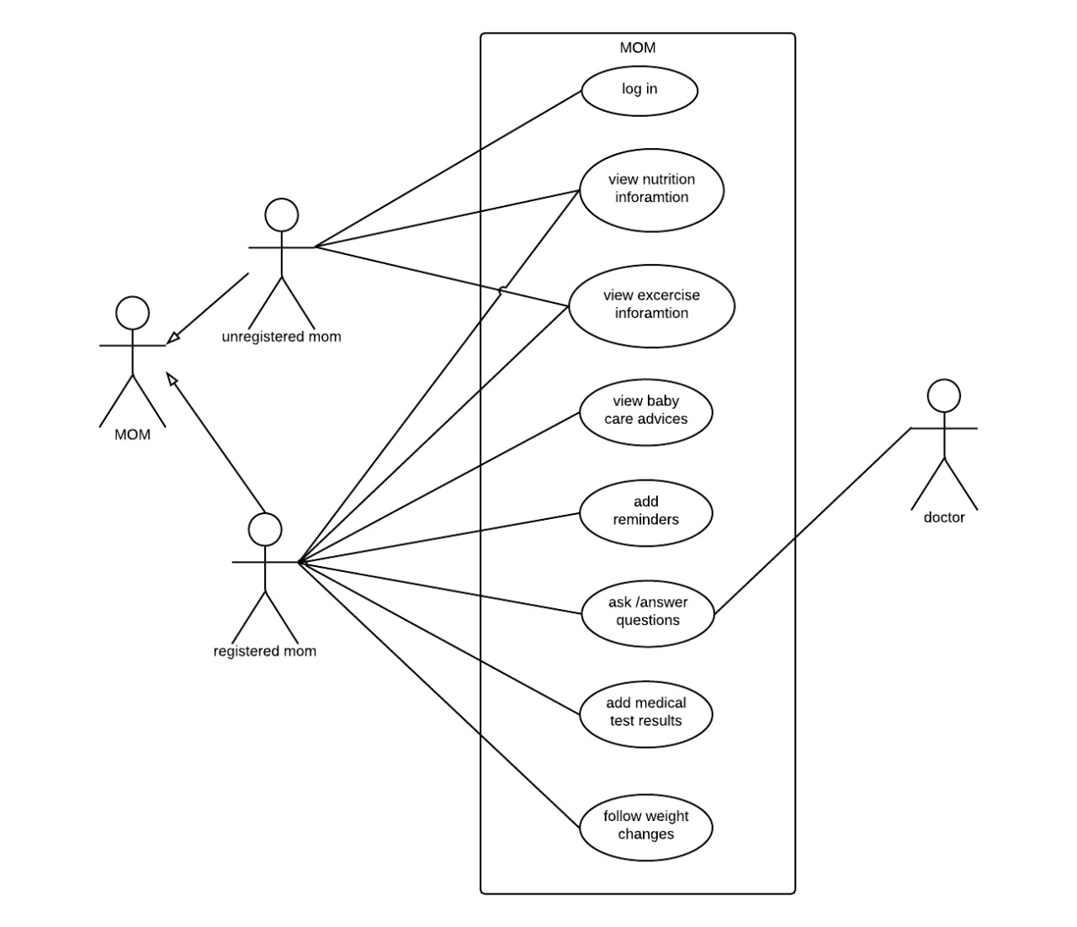**Sequence Diagrams**

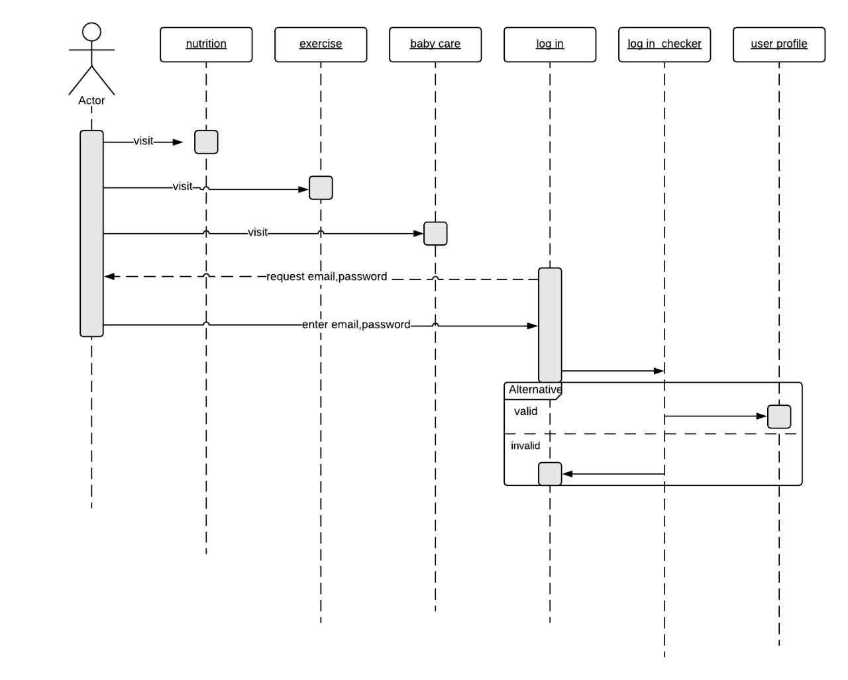

**Non-Functional Requirements**

Non-functional requirements describe what a system has to be. These are statements that support auditability and uptime. Non-functional security requirements are statements like “Audit logs shall be verbose enough to support forensics.” Supporting auditability is not a direct functionality requirement, but it supports auditability requirements from regulations that may apply.

**[NFR_1] <Security> Requirements**

A security requirement is a goal set out for an application at its inception. Every application fits a need or a requirement. Some applications allow customers (mothers) to perform actions without needing help from an anyone. Just as those actions and outcomes are laid out as goals for the final application, the security goals must also be included. A security requirement is not a magic wand that you can wave at an application and say “Thou shalt not be compromised by hackers” any more than a New Year’s resolution is a magic wand that you can wave at yourself to lose weight. Just like a resolution to lose weight, being vague is a recipe for failure. How much weight? How will you lose it? Will you exercise, diet, or both? What milestones will you put out there? In security, the same types of questions exist. What kinds of vulnerabilities are you looking to prevent? How will you measure whether your requirement is met? What preventative measures will you take to ensure that vulnerabilities aren’t built into the code itself?

**[NFR_2] <Usability> Requirements**

An interface should be easy to learn how to use and easy to remember how to use. The latter pertains especially to devices that require infrequent use. Users should not be required to consult a manual each time they need to use a kitchen blender for instance. Bank ATMs and web-based forms, which may be used by anyone, should be simple to use the first time around without instructions.

Usability Requirements for an interface design should support the following from the perspective of its primary users:

* Efficiency of use:  goals are easy to accomplish quickly and with few or no user error
* Intuitiveness:  the interface is easy to learn and navigate; buttons, headings, and help/error messages are simple to understand
* Low perceived workload:  the interface appears easy to use, rather than intimidating, demanding and frustrating

**[NFR_3] <Performance> Requirements**

The system must be interactive and the delays involved must be less. So, in every action-response of the system, there are no immediate delays. In case of opening windows forms, of popping error messages and saving the settings or sessions there is delay much below 2 seconds, in case of opening databases, sorting questions and evaluation there are no delays and the operation is performed in less than 2 seconds for opening, sorting, computing, posting > 95% of the files. Also, when connecting to the server the delay is based editing on the distance of the 2 systems and the configuration between them so there is high probability that there will be or not a successful connection in less than 20 seconds for sake of good communication.

**[NFR_4] <Reliability> Requirements**

Reliability is usually defined as the probability that a product will operate without failure for a specified number of uses (transactions) or for a specified period of time. To be truly testable a requirement for software reliability should be stated as a forecast and the test results should indicate the confidence level associated with the forecast that the product will meet the requirement.